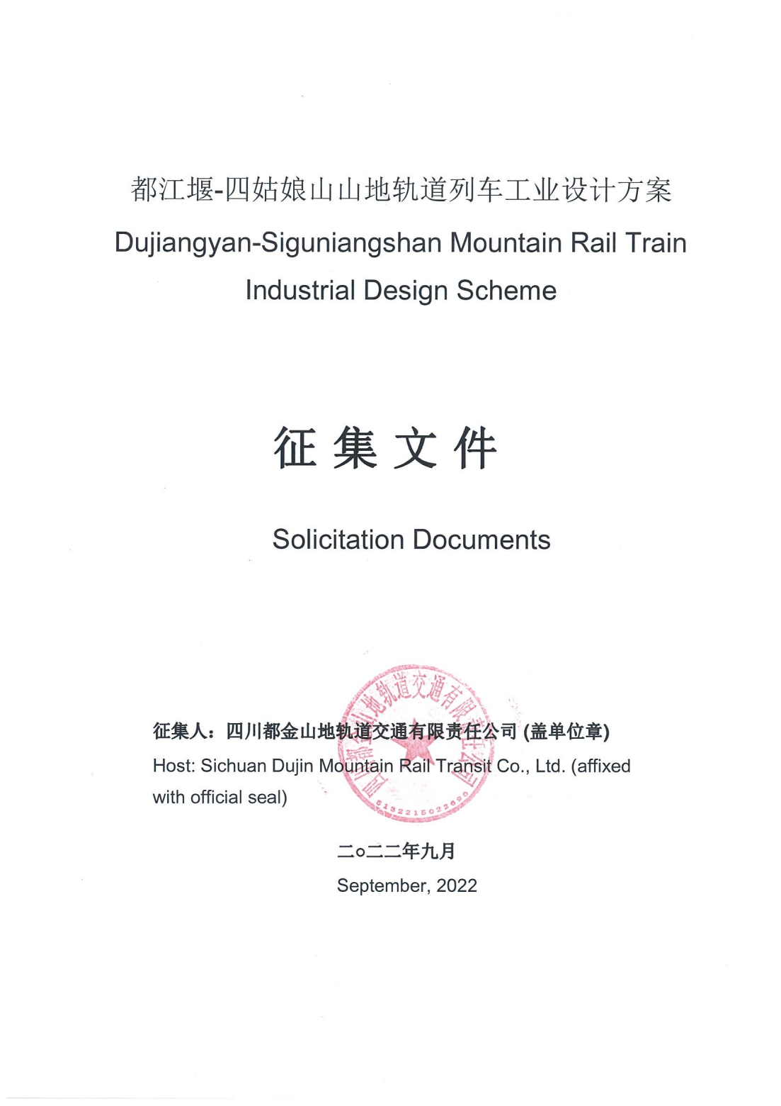

目 录
Table of Contents

目录
Table of Contents
第一章 征集公告 Chapter I Solicitation Announcement 1
第二章 应征须知前附表及应征须知 Chapter II Pre-Schedule of Application Instructions and Application Instructions 8
第三章 评审方法和标准 Chapter III Review Methods and Standards 24
第四章 技术标准与要求 Chapter IV Technical Standards and Requirements 29

- 征集公告

Chapter I Solicitation Announcement

一、征集条件
I. Solicitation conditions
1.本征集项目都江堰-四姑娘山山地轨道列车工业设计方案征集，项目业主为四川都金山地轨道交通有限责任公司，建设资金来自企业自筹（资金来源），出资比例为100%，征集人为四川都金山地轨道交通有限责任公司，征集代理机构为 中通建设工程管理有限公司 。现对该项目的山地轨道列车工业设计方案进行公开征集。
1. The Project for solicitation is the Industrial Design Scheme of Dujiangyan-Siguniangshan Mountain Rail Train. The Project owner is Sichuan Dujin Mountain Rail Transit Co., Ltd., and construction fund is self-raised by the enterprise (funding source), with a capital contribution ratio of 100%. The Host is Sichuan Dujin Mountain Rail Transit Co., Ltd., and the solicitation agency is Sinothru Construction Engineering Management Co., Ltd. The industrial design scheme of mountain rail train under the Project now opens for solicitation.

二、项目概况：
II. Project overview:

1.项目建设地点：成都市、阿坝藏族羌族自治州。
1. Project construction site: Chengdu City and Aba Tibetan and Qiang Autonomous Prefecture.
2.项目建设规模：都四线路起于都江堰，成灌高铁都江堰站，经虹口、龙池、映秀镇、耿达、卧龙，止于小金县四姑娘山镇，线路正线长度123.2公里，正线桥隧总长122.748km，占比98.7%。其中：桥梁长35.011km，占比28.15%；隧道长87.737km，占比70.5%，全线新建车站12个，包括都江堰、虹口、卧龙、映雪、邓生沟、巴朗山、四姑娘山站等项目位于横断山脉东缘，由四川盆地成都平原向青藏高原东部边缘构造强烈复合之高山峡谷带过渡区行进。
2. Project construction scale: Starting from Dujiangyan Station of Chengdu-Dujiangyan High-Speed Railway, Dujiangyan, the Dujiangyan-Siguniangshan Line passes through Hongkou, Longchi, Yingxiu, Gengda, Wolong, and terminates at Siguniangshan Town, Xiaojin County. The main track is 123.2 km long, with the total length (122.748 km) of bridges and tunnels accounting for 98.7% of the main track, of which: Bridges are 35.011 km long, accounting for 28.15%; tunnels are 87.737 km long, accounting for 70.5%. Twelve newly-built stations along the whole line, such as Dujiangyan, Hongkou, Wolong, Yingxue, Dengshenggou, Balang Mountain and Siguniang Mountain stations, are located at the eastern edge of Hengduan Mountains, from the Chengdu Plain of Sichuan Basin to the transition zone of alpine gorge belt with strong composite structures at the eastern edge of the Qinghai-Tibet Plateau.

3.征集范围：应征公司及团体应提供以下文件及设计方案：

3. Solicitation scope: Application companies and organizations should provide the following documents and deign schemes:
（1）外观设计
(1) Exterior design
提供2套旅游列车外观设计。外观应该具备鲜明的旅游属性，设计兼具国际化与地域性特色，能够吸引游客，便于旅游宣传推广。
Two sets of exterior designs for tourist train should be provided, with distinct tourism attributes in the exterior, and both international and regional characteristics in the design, so as to attract tourists and facilitate tourism publicity and promotion.
提供1套通勤列车外观设计。通勤车主要满足当地居民的出行及运输的需求，体现该项目精准扶贫的设计定位，外观应该具备明显的通勤列车造型特征。
One set of exterior design for commuting train should be provided. The commuting trains are mainly designed to meet travel and transport needs of local residents. To reflect the Project's design positioning of targeted poverty alleviation, the exterior should be distinctly featured by the styling of commuting train.
（2）客室设计
(2) Cabin design
提供3套客室空间设计：
Three sets of cabin designs should be provided:
商务型车厢，为乘客创造优质的出行体验，建议座椅布局为1+1的布置。
Business coach offers high-quality travel experience to passengers. 1 + 1 seat layout is recommended.
舒适型车厢，提供舒适且多元的旅行体验，建议座椅布局为2+1的布置，空间布局包含餐饮、娱乐功能。
Comfort coach provides comfortable and diverse travel experience. 2 + 1 seat layout is recommended, with the space layout taking catering and entertainment functions into consideration.
经济型车厢，满足一般旅游者出行乘坐需求，建议座椅布局为2+2的布置。
Economy coach meets travel needs of general tourists. 2 + 2 seat layout is recommended.
以上三种车厢提供多角度三维渲染效果图。
Multi-angle 3D renderings for the above three types of coaches should be provided.
（3）司机室设计
(3) Driver's cab design
设计创意1套司机室内部造型（包括司机台）。提供至少1-2个视角的渲染效果图。
Design and create one set of interior styling of the driver's cab (including the driver's desk), with the renderings from at least 1-2 angles of view provided.
（4）车辆品牌视觉形象及衍生品设计
(4) Vehicle brand visual image and derivative design
设计创意1套旅游列车文化标识及延展运用，包括但不限IP形象、伴手礼、旅游纪念品设计等。
Design and create one set of cultural signs and extended application of tourist train, including but not limited to IP image, souvenir, and tourism souvenir design, etc.

4.标段划分：本次按1个标段进行征集。
4. Division of bid section: This solicitation is carried out as one bid section.

三、应征人资格要求
III. Applicant qualification requirement
1.资质要求：应征人是响应征集、参加征集竞争的法人或者团体。允许联合体进行征集。如为中国境外（包括国外及港澳台地区）设计单位，应当按照中华人民共和国有关法律、法规办理相应的市场准入手续。
1: Qualification requirement: The Applicants is a legal person or organization that responds to bidding and participates in solicitation competition. Solicitation of consortium is allowed. If the applicant is a design unit outside of China (including foreign countries and Hong Kong, Macao and Taiwan regions), it should go through the corresponding market access procedures in accordance with the relevant laws and regulations of the People's Republic of China.
2.业绩要求：应征人应至少提供1项近五年（2017年1月1日至应征截止时间，以合同签订时间为准）正在设计或新承接的轨道交通工具工业设计方案设计业绩。
2. Achievement requirements: The Applicants should provide at least one design achievement of industrial design scheme of rail transit means being designed or newly undertaken in the past five years (from January 1, 2017 to the application deadline, subject to the contract signing time).

3.本次设计方案征集接受联合体应征。
3. The solicitation of design scheme accepts consortium applications.

四、本次征集活动程序
IV. Procedures for the solicitation
本次活动面向全球公开征集设计方案，采用邀请征集和公开报名两种方式。
Facing the world, design schemes are solicited publicly with two methods of invitation solicitation and open application.

1.征集文件获取
1. Acquisition of solicitation documents
凡有意参加方案应征的单位，请于2022年9月22日（北京时间）起在中国招标投标公共服务平台（网址：http://www.cebpubservice.com/)或蜀道集团投资集团有限责任公司（https://www.shudaojt.com）或四川蜀道新制式轨道集团有限责任公司官网（网址：https://www.scgdjt.com/）免费获取征集文件，征集人不提供其他任何报名和应征文件获取方式。
For all units interested in participating in the scheme application, pleased check the official websites of China Tendering and Bidding Public Service Platform (website: http://www. cebpubservice.com/),Shudao Investment Group Co., Ltd. (website: https://www.shudaojt.com) and Sichuan Shudao New System Rail Group Co., Ltd. (website: https://www.scgdjt.com/) to acquire the solicitation documents for free. The Host does not provide any other ways to apply and acquire application documents.
获取征集文件后，如有疑问，请于2022年10月6日前，将需要解答的问题以书面形式（加盖应征人鲜章）发送至邮箱。
In case of any questions emerging after acquisition of solicitation documents, please send such questions to be answered in written form (affixed with fresh seal of the applicant) to the mailbox before 10/06, 2022.

2.方案设计及成果提交
2. Schematic design and submission of deliverables
应征文件递交的截止时间：2022年11月30日上午10时00分（北京时间），递交地点为：四川蜀道新制式轨道集团有限责任公司本项目开选室（四川省成都市锦江区三色路163号银海芯座B座23层），方案现场介绍和说明在2022年11月30日下午14时00分（北京时间）进行（请提前准备PPT），介绍时间控制在10分钟以内。逾期送达或者未送达指定地点或者不按照征集文件要求密封的应征文件，征集人将予以拒收。
Deadline for submission of application documents: 10:00 am 11/30, 2022 (Beijing time), and submission location: Project Selection Initiation Room of Sichuan Shudao New System Rail Group Co., Ltd. (23F, Tower B, Yinhai Star, No. 163 Sanse Road, Jinjiang District, Chengdu City, Sichuan Province). The on-site presentation and explanation of the scheme will be carried out at 14:00 pm on 11/30,, 2022 (PPT is prepared in advance), with the presentation time controlled within 10 minutes. The Host will reject application documents that are overdue or not delivered to the designated place or not sealed as required in solicitation documents.
当采取远程开选方式时，具体事项另行通知。
In case of remote selection initiation, the specific matters will be notified separately.
当接受的应征文件不足三家时，应征文件原封退回。
In case of less than three application documents accepted, the application documents submitted will be returned unopened.

3.评选时间：
3. Evaluation time:

（1）.初选：2022年11月30日，由主办方和行业专家组织评选，各征集公司需准备汇报文件进行线上答辩。

(1). Preliminary selection: On November 30, 2022, the organizer and industry experts will organize the selection. Each solicitation company needs to prepare the report documents for online defense.

（2）.复选：2022年12月，由主办方和行业专家组织评选，公布获奖结果。

(2). Re-selection: In December 2022, the organizer and industry experts will organize the selection and release the award results.
- 征集费用支付
V. Payment of solicitation fees

（一）征集分为三个阶段征集，分别为邀请阶段、初评阶段、复赛阶段，初评阶段评选不超过6名应征人入围进行方案深化设计，复赛阶段针对深化的方案设计评选出前3名。
(1) The solicitation is in three stages, namely the invitation stage, preliminary evaluation stage and competition stage. In the preliminary evaluation stage, no more than six applicants will be shortlisted for development design of scheme. In the competition stage, top three applicants will be selected according to the development scheme designs.

1.邀请阶段
1. Invitation stage
邀请参与征集的设计公司，基础征集费10w（人民币）。
Invite design companies to participate in the solicitation, with the basic solicitation fee of RMB 100,000 yuan.
邀请阶段，受邀公司应当提前缴纳/万作为履约保证金，初评阶段按综合得分由高到低综合得分60分及以上的应征人，将有资格获得10万元的基础征集费。
In the invitation stage, the invited companies should pay / ten thousand yuan in advance as the performance deposit. In the preliminary evaluation stage, applicants with a comprehensive score of 60 points or above from high to low will be eligible for the basic solicitation fee of 100,000 yuan.

2.初评阶段：
2. Preliminary evaluation stage:
初评得出入围奖6名，奖励金额25w。
Six applicants will be awarded 250,000 yuan for being shortlisted in the preliminary evaluation.
初评阶段按综合得分由高到低综合得分75分以上的前六名为中选候选人，参与第二阶段的深化设计，不足六名按实际情况确定；当综合得分75分以上的应征人不足3名时，不推荐中选候选人。初评阶段方案入围奖各为25万元，初评阶段入围的应征人，只有在复赛阶段按照征集人要求递交了方案文件时，才能获得此费用。
In the preliminary evaluation stage, the top six applicants with a comprehensive score of over 75 points from high to low are the candidates selected to participate in the development design in the second stage; if there are less than six qualified applicants, they will be determined according to the reality; if there are less than three applicants with a comprehensive score of over 75 points, no selected candidate will be recommended. Applicants with shortlisted schemes in the preliminary evaluation stage will be awarded 250,000 yuan respectively. They could only receive the fee after submitting the scheme documents as required by the Host in the competition stage.

3.复赛阶段：
3. Competition stage:
在入围的作品基础上，终评得出一等奖1名、二等奖1名、三等奖1名。
Based on shortlisted works, one first prize winner, one second prize winner and one third prize winner will be finally decided.
复赛阶段针对入围的应征人的深化方案设计，按综合得分由高到低评选出前3名，第一名酬金60万元并颁发证书，第二名酬金30万元并颁发证书，第三名酬金20万元并颁发证书（酬金均不包含第一阶段入围奖25万元）。第一名作为中选人完成深化设计，全过程配合车辆制造等相关单位完成列车工业设计（不另外支付费用）。
In the competition stage, top three development scheme designs of shortlisted candidates will be selected according to the comprehensive scores from high to low. The first place winner will be awarded 600,000 yuan with a certificate issued. The second place winner will be awarded 300,000 yuan with a certificate issued. The third place winner will be awarded 200,000 yuan with a certificate issued (the prizes do not include the shortlist award of 250,000 yuan in the first stage). The first place winner will complete the development design as the selected agency, and cooperate with vehicle manufacturing and other relevant units in completion of the industrial design of train in the whole process (without additional payment).
所有的费用均为含增值税含税价，在支付费用之前，应征人都应向征集人提供增值税专用发票。
All payments are VAT inclusive. Before the payment is made, the applicant should provide the Host with a special VAT invoice.

六、发布公告的媒介
VI. Announcement-issuing media
本次征集公告在蜀道集团投资集团有限责任公司（网址：https://www.shudaojt.com/）、四川蜀道新制式轨道集团有限责任公司官网（网址：https://www.scgdjt.com/）、中国招标投标公共服务平台（网址：http://www.cebpubservice.com/）上发布。
The Solicitation Announcement will be issued on the official website of Shudao Investment Group Co., Ltd. (website: https://www.shudaojt.com/), Sichuan Shudao New System Rail Group Co., Ltd. (website: https://www.scgdjt.com/) and China Tendering and Bidding Public Service Platform (website: http://www. cebpubservice.com/).

七、联系方式
VII. Contact information
征集人：四川都金山地轨道交通有限责任公司
Host: Sichuan Dujin Mountain Rail Transit Co., Ltd.
地址：都江堰市观景路 833 号
Address: No.833 Guanjing Road, Dujiangyan City
联系人：王女士
Contact: Ms. Wang
电话：028-68178711
Tel: 028-68178711

招标代理机构：中通建设工程管理有限公司
Bidding agency: Sinothru Construction Engineering Management Co., Ltd.
地址：成都市高新区吉庆三路333号蜀都中心二期1栋4单元2704
Address: 2704, Unit 4, Building 1, Shudu Center Phase II, No.333 Jiqing 3rd Road, High-tech Zone, Chengdu
联 系 人：张女士
Contact: Ms. Zhang
电 话：028-83226053
Tel: 028-83226053

应征回执
Application Receipt

四川都金山地轨道交通有限责任公司：
Sichuan Dujin Mountain Rail Transit Co., Ltd.
《都江堰-四姑娘山山地轨道列车工业设计方案征集文件》 已经下载，我公司拟参与此次方案征集，如有补遗或其他通知，请同时发送至以下邮箱： 。
Having downloaded the Solicitation Documents for Industrial Design Scheme of Dujiangyan-Siguniangshan Mountain Rail Train, our Company proposes to participate in the scheme solicitation. Should you have any supplementary documents or other notices, please promptly send them to the following mailbox: .
单位名称： (全称、加盖公章) =====================================================================
Unit's name: (full name, affixed with official seal) =====================================================================
注：各应征人下载征集文件后，请将上述回执发送到征集人邮箱：3562719455@qq.com
Note: After downloading the solicitation documents, each applicant should send the above Receipt to the Host’s mailbox: 3562719455@qq.com
- 应征须知前附表及应征须知

Chapter II Pre-Schedule of Application Instructions and Application Instructions

一、应征须知前附表
I. Pre-Schedule of Application Instructions
项号  Item number | 内 容  Content | 说 明 与 要 求  Instructions and requirements
1 | 项目名称  Project name | 都江堰-四姑娘山山地轨道列车工业设计方案征集  Solicitation for Industrial Design Scheme of Dujiangyan-Siguniangshan Mountain Rail Train
2 | 项目概况  Project overview | 同征集公告。  Same as Solicitation Announcement.
3 | 征集方式  Solicitation method | 公开征集。  Open solicitation.
4 | 征集范围  Solicitation scope | 同征集公告。  Same as Solicitation Announcement.
5 | 设计周期  Design cycle | 满足征集人要求。  Meeting the Host's requirements.
6 | 应征人资格要求  Applicant qualification requirements | 同征集公告。  Same as Solicitation Announcement.
7 | 应征保证金  Application deposit | 不需要。  Not required.
8 | 履约保证金  Performance deposit | 不需要。  Not required.
9 | 应征文件有效期  Validity period of application documents | 60 日历天(从征集截止之日算起，如征集人因工作需要则相应顺延)。  60 calendar days (calculated from the deadline of the solicitation, and it will be postponed accordingly upon the work request of the Host).
10 | 现场踏勘  Site visit | 不组织，由应征人自行踏勘。  Not organized. Applicants may visit the site by themselves.
11 | 应征人提出问题 的截止时间  Deadline for the applicant to raise questions | 应征人提出问题截止时间：2022 年10月6日下午 18 时 00 分前 (应征人在  此时间之后提出的问题，征集人不再进行澄清和答复) ，将需要解答的问题  Deadline for applicants to raise questions: Before 18:00 pm, 10/06, 2022  (the Host will not clarify and answer the questions raised by applicants after this time), the questions to be answered  以书面形式 (加盖应征人鲜章) 发送至邮箱：3562719455@qq.com。  should be sent in written form (affixed with fresh seal of the applicant) to the mailbox: 3562719455@qq.com.  征集人在应征文件递交截止时间 15 日之前以澄清或补遗的形式在征集公告发布媒体上公布，应征人自行获取，应征人未自行获取本项目所有澄清及补遗文件， 由此造成的后果由应征人自行承担。  The Host should release the clarification or supplement 15 days before the deadline for submission of the application documents. The applicant should acquire them by itself. If the applicant fails to acquire all clarification and supplementary documents by itself, it should bear the consequences arising therefrom by itself.
12 | 应征文件份数  Number of copies of application documents | 应征文件份数：一份正本，二份副本， 电子文档(光盘或 U 盘)。  Number of copies of application documents: One original, two copies, electronic documents (CD or USB flash drive).

13 | 装订要求  Binding requirements | (1) 应征文件商务部分 (A4)、设计方案文本 (A3) 应分开装订，且采用粘贴方式装订，不得采用活页夹等可随时拆换的方式装订，不得有零散页。  (1) The business part (in A4) and design scheme text (in A3) of the application documents should be bound separately. The documents should be bound by pasting instead of loose-leaf binder and other removable binding methods. No scattered pages are allowed.  (2) 若同一册内容较多，可装订成若干分册，并在封面标明次序及册数。  (2) If there are many contents in the same volume, it could be separated into several volumes, with the volume order and number of copies indicated on the cover.
14 | 应征文件内容要 求  Content requirements of application documents | 详见技术标准与要求  See Technical Standards and Requirements for details
15 | 评审方法  Review method | 综合评估法  Comprehensive review method
16 | 应征文件递交 时间及地点  Submission time and location of application documents | 递交时间：2022 年2022年11月30日上午9时00分至 10时 00分(北京时间)。  Submission time: From 9:00 am to10:00amon11/30, 2022 (Beijing time).  由于当前疫情的不确定性，本次征集方案可能采取远程开选、远程演示 PPT 方式。当采用远程开选时，纸质文件可通过快递送达，邮费由应征人承担。收件人信息、远程开选会议室等具体事项另行通知。采用现场开选时， 不接受快递送达的应征文件。  Due to the uncertainty of COVID-19 pandemic at present, the method of remote selection initiation and remote PPT presentation may be adopted for the scheme solicitation. In case of remote selection initiation, paper documents could be delivered by courier, with the postage borne by the applicant. The specific matters concerning the recipient information and the remote selection initiation meeting room will be notified separately. If on-site selection initiation is adopted, application documents delivered by courier will not be accepted.  递交地点： 四川省成都市锦江区三色路 163 号银海芯座 B 座 23层本项目开选室。Submission location: Project Selection Room, 23F, Tower B, Yinhai Star, No. 163 Sanse Road, Jinjiang District, Chengdu City, Sichuan Province.
17 | 应征文件递交的 截止时间即开选  时间及开选地点  Deadline for submission of application documents, namely the selection initiation time and location | 应征文件递交的截止时间：2022 年11月30日上午 10时 00 分(北京时间)。 开选地点： 四川省成都市锦江区三色路 163 号银海芯座 B 座 23 层本项目开选室。  Deadline for submission of application documents: 10:00 am on 11/30, 2022 (Beijing time). Selection initiation location: Project Selection Room, 23F, Tower B, Yinhai Star, No. 163 Sanse Road, Jinjiang District, Chengdu City, Sichuan Province.
18 | 评审委员会的组建  Formation of review jury | 评审委员会按相关规定进行组建。评审专家人数：7人  The review jury is formed according to relevant regulations. Number of review experts: 7 .
19 | 中选候选人  Selected candidates | 评审委员会根据应征人得分从高到低排定顺序，推荐综合得分75分以上的前六名为第一阶段中选候选人，参与第二阶段的深化设计，不足六名按实际情况确定，综合得分75分以上的应征人不足3名时，不推荐中选候选人。  The review jury will rank the applicants according to their scores from high to low, and recommend the top six applicants with a comprehensive score over 75 points as the candidates selected in the first stage to participate in the design development in the second stage; if there are less than six qualified applicants, they will be determined according to the reality; if there are less than three applicants with a comprehensive score over 75 points, no selected candidate will be recommended.
20 | 评审结果公示  Announcement of review results | 第一阶段、第二阶段结果均在发布征集公告的网站公示三个工作日。  The results of the first stage and the second stage will be announced on the websites releasing Solicitation Announcement for three working days.
21 | 其他：征集服务费支付标准：参照国家计委关于印发《招标代理服务收费管理暂行办法》 的通 知 (计价格【2002】1980 号) 规定的招标代理服务费收费标准下浮 30%计取，入围的应征人按 补偿金额作为基准价计取征集服务费。  Others: Solicitation service fee payment standard: The solicitation service fees are calculated as per 30% lower than the bidding agency service fee regulated by the notice by State Planning Commission on printing and issuance of Interim Measures for the Administration of Bidding Agency Service Fee (JJG [2002] No.1980), and the shortlisted applicants should calculate and collect solicitation service fees according to the compensation sum as the benchmark price.  应征人在征集活动中涉及的一切费用，不管应征结果如何，均由应征人自己承担。  All fees generated from the solicitation activities, regardless of the application result, are borne by the applicant itself.

二、应征须知 (正文)
II. Application Instructions (text)

1.总 则
1. General provisions

1.1 说明
1.1 Description
1.1.1 征集人：四川都金山地轨道交通有限责任公司。
1.1.1 Host: Sichuan Dujin Mountain Rail Transit Co., Ltd.
1.1.2 应征人的资格条件：符合应征前附表应征人的资质要求。
1.1.2 Qualifications of the applicant: Meeting the qualification requirements of the Pre-Schedule of Application Instructions
1.1.3 征集内容：详见应征须知前附表。
1.1.3 Solicitation contents: Please see the Pre-Schedule of Application Instructions for details.

1.2 资金来源
1.2. Funding source
1.2.1 资金来源： 自筹资金。
1.2.1 Funding source: Self-raised funds.
1.2.2 出资比例：100%。
1.2.2 Contribution ratio: 100%.

1.3 征集费用及征集货币
1.3 Solicitation fees and solicitation currency
1.3.1 应征人应承担其编制应征文件与递交应征文件所涉及的一切费用。不管应征结果如何，征 集人对上述费用不负任何责任，均由应征人承担。
1.3.1 The applicant should bear all the fees generated from the preparation and submission of the application documents. Regardless of the application result, the Host is not responsible for any of the aforementioned fees and they will be borne by the applicant.
1.3.2 应征报价及中标后的服务费均采用人民币支付和结算。
1.3.2 The application quotation and the service fee after winning the bid will be paid and settled in RMB.
1.3.3 由于应征人原因使开、评审失败的，责任人应承担相应的费用和责任。
1.3.3 If the bid opening or review fails due to the applicant's reasons, the responsible person should bear the corresponding fees and responsibilities.
1.3.4 参加本次征集的所有版权等归征集人所有，应征人不得以征集人使用其征集方案提出异议和侵权争议。
1.3.4 All copyrights of participating in the solicitation are owned by the Host, and the applicant may not raise objections and infringement disputes based on the Host's use of its solicitation scheme.

1.4 现场考察
1.4 Site visit
1.4.1 征集人不组织现场踏勘，详见应征须知前附表。
1.4.1 The Host will not organize a site visit. Please see the Pre-Schedule of Application Instructions for details.

1.5 征集答疑
1.5 Solicitation Q&A
1.5.1 应征人应在领取征集文件和相关资料后的征集答疑， 以征集文件应征须知前附表的相关规 定办理，否则，后果由应征人自行承担。
1.5.1 After receiving the solicitation documents and relevant materials, the applicant should handle solicitation Q&A by adhering to the requirements of the Pre-Schedule of Application Instruction in the solicitation documents, otherwise, the applicant should bear the consequences by itself.
1.5.2 征集答疑的目的，是澄清并解答应征人在查阅征集文件后和现场考察后，可能提出的有关 本次征集的问题。
1.5.2 The purpose of the solicitation Q&A is to clarify and answer the questions regarding the solicitation that may be raised by the applicant after consulting the solicitation documents and site visit.

2.征集文件
2. Solicitation documents

2.1 征集文件的组成
2.1 Composition of solicitation documents
2.1.1 本工程的征集文件包括下列文件及所有发出的补充资料及征集答疑内容。征集文件包括下列内容：
2.1.1 The solicitation documents for the Project include the following documents, all the supplementary materials issued and the contents of the solicitation Q&A. The solicitation documents include the following contents:

第一章Chapter I
第二章Chapter II
第三章Chapter III

第四章Chapter IV
第五章Chapter V

征集公告
Solicitation Announcement

应征须知前附表及应征须知
Pre-Schedule of Application Instructions and Application Instructions

评审方法和标准
Review Methods and Standards

技术标准与要求
Technical Standards and Requirements

应征文件格式
Format of Application Documents

2.1.2 应征人应仔细阅读征集文件，按征集文件的规定与要求编写应征文件。
2.1.2 The applicant should read the solicitation documents carefully, and prepare them in accordance with the provisions and requirements of the solicitation documents.
2.1.3 应征人应认真检查征集文件是否完整，若发现缺页或附件不全时，应及时向征集人提出，并 要求补齐，否则后果自负。
2.1.3 The applicant should carefully check whether the solicitation documents are complete. If any missing pages or incomplete attachments are found, it should raise the issue to the Host in time and request to supplement, otherwise the consequences will be borne by itself.

2.2 征集文件的澄清和解释
2.2 Clarification and explanation of solicitation documents
2.2.1 应征人将要求澄清和解答的问题以征集文件应征人须知前附表的有关规定办理。
2.2.1 The applicant follow relevant provisions of Pre-Schedule of Application Instructions in solicitation documents to handle questions to be clarified and answered.
2.2.2 征集文件的解释和解释权归征集人所有。
2.2.2 The solicitation document interpretation and right to interpret belongs to the Host.

2.3 征集文件的修改
2.3 Modification of solicitation documents
2.3.1 征集文件发出后，征集人可以按征集文件应征人须知前附表规定的有关要求对征集文件进行必要 的修改。
2.3.1 After the solicitation documents are issued, the Host may make necessary modifications to the solicitation documents according to the relevant requirements specified in the Pre-Schedule of Application Instructions in the solicitation documents.
2.3.2 征集文件的澄清、修改、补充等内容均以书面形式明确的内容为准。当征集文件、征集文件的澄 清、修改、补充等在同一内容的表述上不一致时，以最后发出的书面文件为准。
2.3.2 The clarification, modification, supplement, etc. of the solicitation documents are subject to the explicit contents in writing. If the solicitation documents, clarification, modification, supplements, etc. of the solicitation documents are inconsistent with the expression of the same content, the final written document shall prevail.
2.3.3 征集文件修改的其他要求按征集文件应征人须知前附表相关要求办理。
2.3.3 Other requirements for the revision of the solicitation documents should be handled in accordance with the relevant requirements of the Pre-Schedule of Application Instructions in the solicitation documents.

3.应征文件
3. Application documents

3.1 应征文件的语言及度量衡单位
3.1 Language and measurement unit of application documents
3.1.1 应征文件和与征集有关的所有文件均应使用汉语语言文字。
3.1.1 The application documents and all documents related to the solicitation should be invariably in Chinese language.
3.1.2 除工程规范另有规定外，应征文件使用的度量衡单位，均采用中华人民共和国法定计量单位。
3.1.2 Unless otherwise specified in the engineering regulations, the units of measurement used in the application documents should be the legal units of measurement of the People's Republic of China.

3.2 应征文件的组成
3.2 Composition of application documents
3.2.1 商务部分应包括下列内容
3.2.1 The business part should include the following
(1)应征函；
(1) Letter of Application;
(2)法定代表人身份证明。
(2) The identity certificate of the legal representative.

(3)法定代表人授权委托书。
(3) Power of Attorney for the legal representative.
(4)征集文件规定的评审需要或其它应填报提交的资料等。
(4) The review needs specified in the solicitation documents or other materials that should be filled in and submitted.
3.2.2 技术部分应包括下列内容
3.2.2 The technical part should include the following
（1）外观方案效果图
(1) Exterior design renderings
（2）客室方案效果图
(2) Cabin design renderings
（3）司机室方案效果图
(3) Driver's cab schematic renderings
（4）动画设计
(4) Animation design
（5）品牌视觉形象及衍生品设计
(5) Brand visual image and derivative design
（6）车辆客室数字化消费场景设计
(6) Vehicle cabin digital consumption scene design
（7）设计说明及CMF列表
(7) Design description and CMF list
3.2.3 无论中标与否，应征人的应征文件均不退还。
3.2.3 No matter whether the bid is won or not, the applicant's application documents will not be returned.

3.3 应征文件有效期
3.3 Validity period of application documents
3.3.1 应征文件在本征集文件规定的征集截止之日起 60 个日历天内有效。
3.3.1 The application documents are valid within 60 calendar days from the solicitation deadline as specified in the solicitation documents.
3.3.2 在特殊情况下，征集人在原定应征文件有效期内可以根据需要向应征人提出延长应征文件有效期的要求，应征人应立即以书面形式向征集人作出书面答复；应征人可以拒绝征集人的要求，其 征集失效。同意延期的应征人，不得因此而提出修改应征文件的要求。
3.3.2 Under special circumstances, the Host may request the applicant to extend the validity period of the application documents as needed within the original validity period of the application documents, and the applicant should immediately give a written reply to the Host; the applicant may also decline the demand of the Host and render its solicitation invalid. The applicant agreeing to the extension must not request to modify the application documents for this reason.

3.4 应征保证金与履约保证金
3.4 Application deposit and performance deposit
3.4.1 应征保证金：详见征集须知前附表
3.4.1 Application deposit: Please see the Pre-Schedule of Application Instructions for details
3.4.2 履约保证金：详见集须知前附表
3.4.2 Performance deposit: Please see the Pre-Schedule of Application Instructions for details

3.5 应征文件的份数和签署
3.5 Number of copies and signing of application documents
3.5.1 应征人应按本须知前附表规定的份数提交应征文件。
3.5.1 Applicants should submit application documents as per number of copies specified in the Pre-Schedule of Application Instructions.
3.5.2 应征文件的副本可采用复印件，字迹应清晰易于辨认，正本和副本如有不一致之处， 以正 本为准；书面文件和电子文档如有不一致之处，以书面文件为准。
3.5.2 Copies of application documents may adopt photocopies with clear and legible handwriting. If there is any inconsistency between the original and the copy, the original shall prevail; if there is any inconsistency between the written document and the electronic document, the written document shall prevail.
3.5.3 应征文件正本和副本的封面或扉页应标明征集人名称、项目名称和应征人名称，并加盖应 征人公章和法定代表人签字或盖章(或委托代理人签字)。
3.5.3 The cover or title page of the original and copy of the application documents should be marked with the name of the Host, the name of the Project and the name of the applicant, and affixed with the official seal of the applicant and the signature or seal of the legal representative (or the signature of the entrusted agent).

4.应征文件的递交
4. Submission of application documents

4.1 应征文件的装订、密封与标志
4.1 Binding, sealing and marking of application documents
4.1.1 应征文件装订要求：应征人应将应征文件装订成册(不得使用活页或抽杆夹装订)，并在应 征文件封面清楚地标明“正本”或“副本”。
4.1.1 Binding requirements for application documents: The applicant should bind the application documents into a book (no loose-leaf or slide-grip binding is allowed), and clearly mark "original" or "copy" on the cover of the application documents.
4.1.2 应征文件密封要求：应征人应将应征文件进行密封(包括电子文档)，密封方式不限，并在密 封外层至少加盖应征人公章。
4.1.2 Sealing requirements for application documents: The applicant should seal the application documents (including electronic documents), the sealing method is not specified, and at least the applicant's official seal should be affixed on the outer sealing layer.
4.1.3 应征文件递交时密封外层应标(注)明：
4.1.3 When submitting the application documents, the outer sealing layer should be marked (noted):

(1)征集人名称：
(1) Name of the Host:
(2) (项目名称) 应征文件；
(2) Application documents of (Project name) ;
(3)应征人名称：
(3) Name of the applicant:
(4) 年 月 日 时开选，此时间以前不得开封；
(4) The selection initiation will be held at on DD/MM/YY , and the seal will not be opened before this time;
4.1.4 如果因应征人遗失应征文件；或应征人迟交应征文件；或因应征文件密封不严而造成过早启封、失密、密封外套爆裂破损等情况，征集人概不负责。
4.1.4 In case that the applicant loses the application documents; or the applicant submits the application documents late; or the application documents are not tightly sealed, resulting in premature unsealing, loss of confidentiality, burst and damage of the sealing envelope, etc., the Host will not be responsible for it.

4.2 应征文件的递交
4.2 Submission of application documents
4.2.1 应征文件的递交按前附表所述的时间、地址执行。
4.2.1 The submission of application documents should be carried out according to the time and address stated in the Pre-Schedule.
4.2.2 征集人可以补充通知的方式，延迟递交应征文件的截止时间。在上述情况下征集人与应征人以前在征集截止时间方面的全部权利、责任和义务，将适用于延迟后新的征集截止时间。应征人也 可放弃征集。
4.2.2 The Host may extend the deadline for submitting application documents by means of supplementary notice. Under the above circumstances, all previous rights, responsibilities and obligations of the Host and the applicant with respect to the solicitation deadline apply to the new solicitation deadline after the extension. And the applicant may also quit the solicitation.

4.3 应征文件的修改与撤回
4.3 Modification and withdrawal of application documents
4.3.1 应征人递交应征文件以后，可以在规定的征集截止期之前，以书面形式向征集人递交补充、 修改或撤回其应征文件的通知。在征集截止期以后，不得更改应征文件。
4.3.1 After the submission of application documents, the applicant may submit a written notice of supplementing, modifying or withdrawing its application documents to the Host before the specified solicitation deadline. No changes to application documents are allowed after the solicitation deadline.
4.3.2 应征人的修改或撤回通知，应按本须知的有关规定进行编制、密封、标志和递交。
4.3.2 The applicant's modification or withdrawal notice should be prepared, sealed, marked and submitted in accordance with the relevant provisions of the Instructions.
4.3.3 征集截止期以后，应征人不得撤回应征文件。
4.3.3 After the solicitation deadline, the applicant must not withdraw the solicitation documents.

5.开选、评审和中标
5. Selection initiation, review and winning of bids

5.1 开选
5.1 Selection initiation
5.1.1 开选会议由征集人组织并主持，所有应征人须准时参加。
5.1.1 The selection initiation meeting is organized and presided over by the Host, and all applicants must attend on time.
5.1.2 开选地点和时间按征集须知前附表规定执行。参加征集的应征人的法定代表人或委托代理 人应出席并签名报到， 以证明其出席开选会议。
5.1.2 The location and time of selection initiation will follow the provisions in the Pre-Schedule of Application Instructions. The legal representative or the entrusted agent of the applicant participating in the solicitation should attend and sign in to prove the presence at the selection initiation meeting.
5.1.3 应征人按征集文件规定递交了应征文件，但法定代表人或委托代理人在开选会中途退场的， 视为认可开选程序，事后不应再对开选程序的公正合法性等提出质疑或异议。征集人不会因应征人中 途退场而宣布其作否决征集处理。
5.1.3 The applicant has submitted the application documents according to the requirements of the solicitation documents, but if the legal representative or the entrusted agent leaves the venue in the middle of the selection initiation meeting, it should be deemed that the selection initiation procedure has been acknowledged, and the fairness and legality of the selection initiation procedure should not be questioned or objected afterwards. The Host will not announce the rejection of the solicitation due to the applicant's withdrawal midway.
5.1.4 应征文件有下列情况之一者，征集人不予受理：
5.1.4 The Host will not accept any of the following situations in the application documents:
(1)逾期送达的或者未送达指定地点的；
(1) The service is overdue or documents are not delivered to the designated place;
(2)未按要求密封的应征文件征集人予以拒收。
(2) Application documents that are not sealed as required will be rejected by the Host.

5.1.5 由开选会议的主持人宣读应征人单位名称，并由应征人的法定代表人或委托代理人签字确认。
5.1.5 The name of the applicant's unit will be read out by the host of the selection initiation meeting, and the applicant's legal representative or entrusted agent should sign for confirmation.

5.2 评审

5.2 Review
5.2.1 评审工作由征集人组建评审委员会组织进行。
5.2.1 The review work will be organized and carried out by the review jury formed by the Host.
5.2.2 本工程采用综合评估法进行评审。
5.2.2 The Project will go through review by adopting the comprehensive review method.
5.2.3 评审程序：详见第三章评审方法和标准
5.2.3 Review procedure: Please see Chapter III Review Methods and Standards for details.

5.3 中选
5.3 Winning
评审结果确定后，征集人在发布征集公告的网站公示入围单位，公示 3 个工作日后若无异议， 由 征集人向入围单位发出通知书。
After the review results are confirmed, the Host will announce the shortlisted units on the websites releasing Solicitation Announcement. If there is no objection in three working days, the Host will issue a notice to the shortlisted units.

6.不正当竞争与纪律监督
6. Unfair competition and disciplinary supervision
6.1 严禁应征人向参与征集、评审工作的有关人员行贿，使其泄露一切与征集、评审工作的有关 信息。在征集、评审期间，不得邀请参与征集、评审工作的有关人员到征集单位参观考察或出席应征 人主办的或赞助的任何活动。
6.1 The applicant is strictly prohibited to bribe the relevant personnel involved in the solicitation and make the latter leak any information related to the solicitation and review. During the solicitation and review, relevant personnel involved in the solicitation and review must not be invited to visit the solicitation unit or attend any activities organized or sponsored by the applicant.
6.2 应征人在征集过程中严禁互相串通、结盟，损害征集的公正性和竞争性，或以任何方式影响 其他应征人参与正当征集。
6.2 During the solicitation process, the applicant is strictly prohibited from collusion or alliance with each other to jeopardize the fairness and competitiveness of the solicitation, or influencing other applicants from participating in the legitimate solicitation in any manner.
6.3 如发现应征人有上述不正当竞争行为，将取消其征集资格或中标资格。
6.3 If the applicant is found to have the above-mentioned unfair competition behavior, it will be disqualified from soliciting or winning the bid.

6.4 征集工作公开接受社会监督。
6.4 The solicitation work is open to social supervision.

第三章 评审方法和标准
Chapter III Review Methods and Standards

一、总则
I. General provisions
征集活动遵循公平、公正、科学、择优的原则依法进行，征集活动及当事人接受依法 实施的监督。本次征集采用综合评分法。
The solicitation activities should be conducted in accordance with the principles of fairness, impartiality, science, and merit-based selection, and the solicitation activities and the parties will be subject to the supervision of the implementation in accordance with the law. This solicitation adopts the comprehensive scoring method.

二、评审组织
II. Review organization
征集人将组建专门的评审委员会对设计文件进行评审，评审委员会由 7 人组成。
The Host will set up a special review jury to review the design documents. The review jury is composed of seven judges.

三、评标过程

III Bid review process

1.符合性审查 1. Compliance review
满足征集公告资格最低要求。
The applicant should meet the minimum requirements of the Solicitation Announcement.

2.评分
2. Scoring
评审委员会对符合性审查合格的应征文件，依照本办法评分标准对对各应征人进行打 分。
The review jury will score each applicant according to the scoring standards of these measures for the application documents that have passed the conformity review.
评委打分采用记名方式独立打分，取算术平均分 (小数点后保留二位小数)。
The judges will use the open vote method to score independently, and take the arithmetic average score (keep two digits after the decimal point).

3.入围原则
3. Shortlisting principles
征集活动遵循公平、公正、科学、择优的原则依法进行，征集活动及当事人接受依法实施的监督。本次征集评选采用综合评分法，接受联合体应征。
The solicitation activities should be conducted in accordance with the principles of fairness, impartiality, science, and merit-based selection, and the solicitation activities and the parties will be subject to the supervision of the implementation in accordance with the law. This solicitation selection adopts the comprehensive scoring method, and accepts consortium application.
评审委员会根据应征人得分从高到低排定顺序，推荐综合得分75分以上的前六名为第一阶段中选候选人，参与第二阶段的深化设计，不足六名按实际情况确定，综合得分75分以上的应征人不足3名时，不推荐中选候选人。综合得分相等时，以“创新性”得分高的优先；其次以“完整性”得分高的优先；再以“可行性”得分高的优先；最后以“市场与行业价值体现”得分高的优先，“市场与行业价值体现”得分也相等的，由征集人自行确定。
2. The review jury will rank the applicants according to their scores from high to low, and recommend the top six applicants with a comprehensive score over 75 points as the candidates selected in the first stage to participate in the design development in the second stage; if there are less than six qualified applicants, they will be determined according to the reality; if there are less than three applicants with a comprehensive score over 75 points, no selected candidate will be recommended. If applicants get the same comprehensive scores, the applicant with higher "innovation" score will be prioritized; then the applicant getting a higher score of "integrity" will be prioritized; and then the applicant with the higher score of "market and industry value embodiment" will be prioritized; if the scores of "market and industry value embodiment" are on a par, the Host will determine the ranking by itself.

4.入围结果
4. Shortlisted results
征集人将入围名单在发布征集公告的媒介进行公示。
The Host will announce the shortlist on the media where the Solicitation Announcement is issued.
四、评审方法：综合评分法。
IV. Review method: Comprehensive scoring method.

一、符合性审查
I. Compliance review
序号  Serial number | 评审因素  Review factors | 评审标准  Review standards
1 | 投标人名称  Bidder's name | 与资质证书副本、营业执照副本或合法的登记证书副本一致。  Consistent with the copy of the qualification certificate, the copy of the business license or the copy of the legal registration certificate.
2 | 资质Qualification | 满足征集公告要求。  Meeting the requirements of the Solicitation Announcement.
3 | 业绩  Achievements | 满足征集公告要求。  Meeting the requirements of the Solicitation Announcement.
4 | 联合体应征  Consortium application | 接受联合体应征。  Consortium application is accepted.
5 | 设计周期  Design cycle | 满足征集人要求  Meeting the Host's requirements
6 | 应征保证金  Application deposit | 满足征集公告要求  Meeting the requirements of the Solicitation Announcement
7 | 应征文件份数、装订  Number of copies and binding of application documents | 按征集文件要求提交  Submitted as required by solicitation documents
8 | 其他  Miscellaneous | 应征文件完全响应第四章技术标准与要求  Application documents fully respond to Chapter IV Technical Standards and Requirements
二、评分标准
II. Scoring standards
序号  Serial number | 细则  Rules | 评分标准  Scoring standards | 分值  Score
1 | 创新性(40分)  Innovation (40 points) | 作品在设计创意、功能体现、材料工艺等方面具有创新性。作品应具有独创性、新颖性、前瞻性，能够展现旅游列车未来发展趋势。本项分值不超过40分。  The works are innovative in design creativity, function embodiment, and material processes, etc. The works should be original, novel and forward-looking to show the future development trend of tourist trains. No more than 40 points are scored in this item. | 40
2 | 可行性(20分)  Viability (20 points) | 作品应符合现代制造技术，具有落地实施的可行性。本项分值不超过20分。  The works should conform to modern manufacturing technology and be viable for implementation. No more than 20 points are scored in this item. | 20
3 | 市场与行业价值体现(15分)  Market and industry value embodiment  (15 points) | 列车设计和车辆品牌视觉衍生品应具有社会普遍认同感与实用性。能对山地轨道旅游列车产业品牌产生良好的影响力。本项分值不超过15分。  Train design and vehicle brand visual derivatives should have a sense of general social identity and practicality, and influence mountain rail tourist train industry brand positively. No more than 15 points are scored in this item. | 15
4 | 完整性(25分)  Integrity (25 points) | 作品应充分表达设计概念的逻辑性。作品不局限于单件产品设计，以系统化的理念提出对旅游列车设计概念。本项分值不超过25分。  The works should fully reflect the logic of design concepts. Not limited to design of single products, the works should put forward design concepts of tourist trains with systematic ideas. No more than 25 points are scored in this item. | 25
注： 1.小数点后保留二位数。
Note: 1. Two digits after the decimal point are kept.
2.各评委成员自行按以上参考分值评分。
2. Each member of the review jury will score according to the above-mentioned reference points.

3.重大事件由评委会集体讨论，须有三分之二或以上的评委签字认可。
3. Major events will be discussed collectively by the jury, and must be signed and approved by two-thirds or more of the judges.

第四章 技术标准与要求

Chapter IV Technical Standards and Requirements

一、项目背景
I. Project background
四川山地旅游资源丰富，是全球高山、极高山旅游资源最密集区域之一。目前四川省山地轨道交通规划11个项目，总里程数1770公里，建设投资约2200亿元。都江堰-四姑娘山山地轨道列车项目（以下简称：都四项目）是蜀道集团首个山地轨道列车项目。
Boasting rich resources of mountain tourism, Sichuan is one of the regions with the most dense alpine and extremely alpine mountain tourism resources in the world. At present, there are 11 mountain rail transit projects planned in Sichuan Province, with a total length of 1,770 km and a construction investment of about 220 billion yuan. Dujiangyan-Siguniangshan Mountain Rail Train Project (hereinafter referred to as "Dujiangyan-Siguniang Mountain Project") is the first mountain rail train project of Shudao Investment Group Co., Ltd.
都四项目作为我国山地轨道交通发展的新篇章，被定位为“民族团结的桥梁、脱贫攻坚的示范、绿色发展的典范”，意在构建“旅游扶贫”交通，围绕山地旅游资源，构建与高速公路、国家铁路干线等骨干交通的连接线，改善旅游资源外部交通条件，以满足景区游客快速便捷通达，同时兼顾沿线居民出行。
As a new chapter in the development of mountain rail transit in China, Dujiangyan-Siguniang Mountain Project is positioned as "a bridge of ethnic unity, a demonstration of poverty alleviation, and a model of green development". It is designed to build the transportation project of "poverty alleviation through tourism", set up a linkage with artery transportation lines such as highways and national main railway lines, improve external transportation conditions of tourism resources, so as to meet the rapid and convenient access of tourists in the scenic area, with the travel of residents along the line taken into account at the same time.
都四线路起于都江堰，成灌高铁都江堰站，经虹口、龙池、映秀镇、耿达、卧龙，止于小金县四姑娘山镇，线路正线长度123.2公里，正线桥隧总长122.748km，占比98.7%。其中：桥梁长35.011km，占比28.15%；隧道长87.737km，占比70.5%，全线新建车站12个，包括都江堰、虹口、卧龙、映雪、邓生沟、巴朗山、四姑娘山站等项目位于横断山脉东缘，由四川盆地成都平原向青藏高原东部边缘构造强烈复合之高山峡谷带过渡区行进。
Starting from Dujiangyan Station of Chengdu-Dujiangyan High-Speed Railway, Dujiangyan, the Dujiangyan-Siguniangshan Line passes through Hongkou, Longchi, Yingxiu, Gengda, Wolong, and terminates at Siguniangshan Town, Xiaojin County. The main track is 123.2 km long, with the total length (122.748 km) of bridges and tunnels accounting for 98.7% of the main track, of which: Bridges are 35.011 km long, accounting for 28.15%; tunnels are 87.737 km long, accounting for 70.5%. Twelve newly-built stations along the whole line, such as Dujiangyan, Hongkou, Wolong, Yingxue, Dengshenggou, Balang Mountain and Siguniang Mountain stations, are located at the eastern edge of Hengduan Mountains, from the Chengdu Plain of Sichuan Basin to the transition zone of alpine gorge belt with strong composite structures at the eastern edge of the Qinghai-Tibet Plateau.
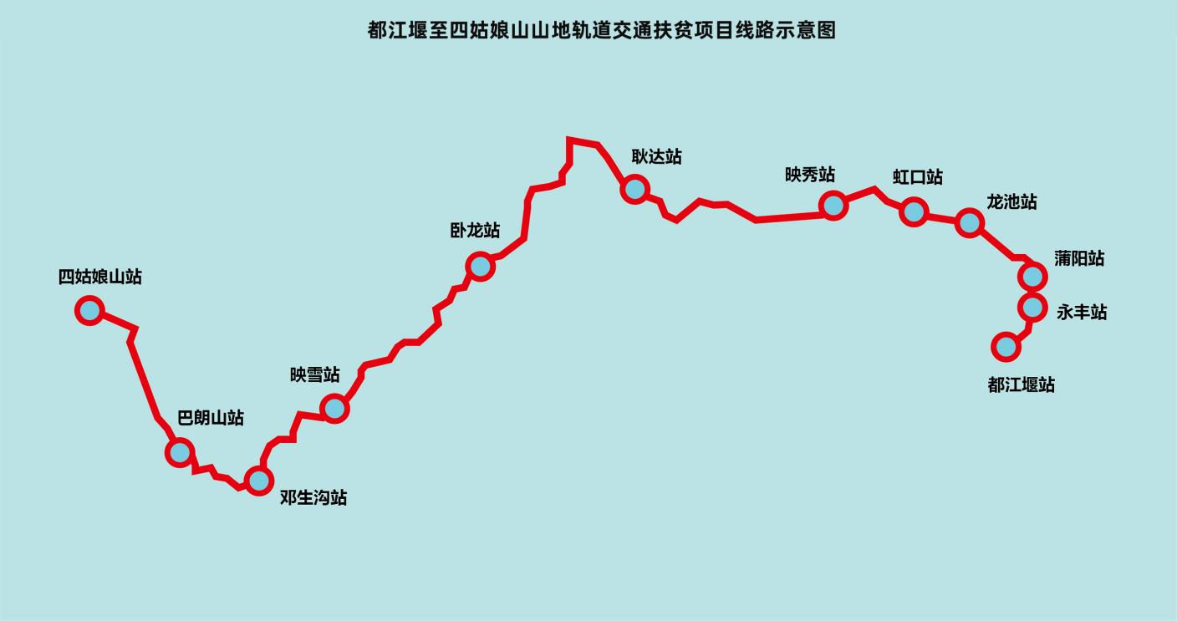
图1 都江堰至四姑娘山山地轨道交通扶贫项目线路示意图
Fig 1 Schematic diagram of the line of Mountain Rail Transit Poverty Alleviation Project from Dujiangyan to Siguniang Mountain

都江堰至映秀属四川盆地亚热带湿润季风气候，降水较多；耿达、卧龙、邓生沟位于青藏高原气候区的东缘，属典型的亚热带内陆山地气候，冬半年天气多晴朗干燥，夏半年温暖湿润；四姑娘山属亚热带季风性气候，区内地形高差悬殊，随海拔高度的变化，山地气候变化明显。
Tucked away in Sichuan Basin, the region from Dujiangyan to Yingxiu has the humid subtropical monsoon climate, with ample precipitation; Gengda, Wolong and Dengshenggou are located at the eastern edge of the Qinghai-Tibet Plateau climate zone, which belongs to the typical subtropical inland mountain climate, with sunny and dry weather in most of the winter half-year and warm and humid weather in the summer half-year; Siguniang Mountain is subject to subtropical monsoon climate. With huge altitude difference in the terrain, the mountain climate varies obviously by the change of altitude.

二、技术要求
II. Technical requirements
1. 编组形式
1. Marshalling form

表1 编组形式
Table 1 Marshalling Form
1 | 车辆型式  Vehicle types | Mc车：带司机室动车，配置一个齿轨转向架和一个粘着转向架  Mc train: CRH train with the driver's cab, equipped with one rack railway bogie and one adhesive bogie
1 | 车辆型式  Vehicle types | M1车：动车，配置两个粘着转向架  M1 train: CRH train, equipped with two adhesive bogies
1 | 车辆型式  Vehicle types | M2车：动车，配置一个齿轨转向架和一个粘着转向架  M2 train: CRH train, equipped with one rack railway bogie and one adhesive bogie
2 | 编组方式  Marshalling mode | 采用4辆编组列车。  Four-car marshalling is adopted.  粘着/齿轨电客车编组方式  Marshalling mode of adhesion/rack railway electric train  +Mc1-M1-M2-Mc2+  +Mc1-M1-M2-Mc2+  + 全自动车钩；  + Full-automatic coupler;  - 半永久性牵引杆。  - Semipermanent draw bar.
3 | 车体材料  Vehicle body material | 铝合金  Aluminium alloy
4 | 车辆最高运行速度  Maximum vehicle operating speed | 120 km/h（粘着路段）  120 km/h (adhesion railway)  30 km/h（齿轨路段，120‰上坡）  30 km/h (rack railway, 120‰ uphill)  20 km/h（齿轨路段，120‰下坡）  20 km/h (rack railway, 120‰ downhill)  40 km/h（齿轨路段，60‰及以下坡道）  40 km/h (rack railway, 60‰ and below downhill)

- 车辆主要尺寸及限界
Main dimensions and limit of vehicle

表2 车辆主要尺寸及限界
Table 2 Main Dimensions and Limit of Vehicle
1 | 车辆长度（两端车钩连接面之间的距离）  Vehicle length (distance between coupler connection surfaces at both ends) | Mc车：19870mm  Mc train: 19,870 mm  M1、M2车：19200mm  M1 train, M2 train: 192,00 mm
2 | 车辆顶面距轨面高度  Height from vehicle top surface to rail surface | ≤3800 mm（新轮，含空调）  ≤3,800 mm (new wheels, including AC)
3 | 车体宽度  Vehicle body width | 2500mm  2,500 mm
4 | 客室地板面距走行轨顶面高度  Height between floor surface of cabin and top surface of running rail | 1100mm  1,100 mm
5 | 车辆定距  Length between bogie centers | 11640mm  11,640 mm
6 | 固定轴距  Rigid wheel base | 粘着转向架： 2300mm  Adhesive bogie: 2,300 mm  齿轨转向架： 2615mm  Rack railway bogie: 2,615 mm
7 | 列车两端车钩连接面间长度  Length between coupler connection surfaces at both ends of the train | 78140mm  78,140 mm
8 | 车钩中心线距轨面高度  Height from coupler center line to rail surface | 720mm  720 mm
9 | 过道宽度  Aisle width | 不小于550mm  No less than 550 mm
10 | 客室内净高  Clear height in cabin | 2100mm（显示屏及门入口区域除外）  2,100 mm (except for display screen and door entrance area)
11 | 车辆客室门间距  Distance between vehicle cabin doors | Mc车：15130mm  Mc train: 15,130 mm  M1、M2车：15800mm  M1 train, M2 train: 15,800 mm  相邻车车门间距： 3400mm  Distance between adjacent doors: 3,400 mm

3. 工业设计输入基础数据
3. Basic data of industrial design input
车辆平断面布置图（包含限界）。电子文件见附件。
Plan and cross-section layout diagrams of vehicle (including limit). See the appendix for electronic documents.

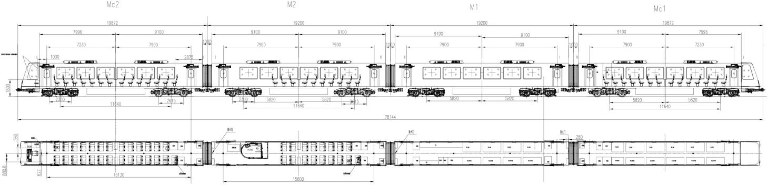

图2 车辆平面布置图
Fig 2 Plan layout diagram of vehicle
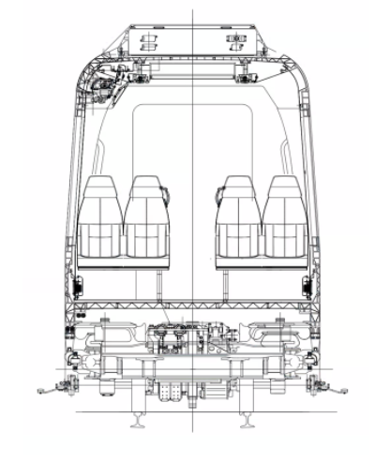
图3 车辆断面布置图
Fig 3 Cross-section layout diagram of vehicle

4.车辆配置清单
4. List of vehicle specifications
（1）车外设备配置
(1) External equipment specifications
车辆外部包括司机室面罩、裙板、头灯、司机室侧门、客室侧门、及 PIS 设备等。具体位置以车辆平断面布置图为基础
The vehicle exterior includes the driver's cab mask, skirt boards, headlamp, driver's cab side door, cabin side door, PIS equipment, etc. The specific locations are based on the plan and cross-section layout diagrams of vehicle.
（2）客室内部设备配置
(2) Cabin internal equipment specifications
- 客室内部设内装( 地板、地板布、门槛、门框、内顶板、侧墙板) 、客室门、设备 ( 窗、座椅、扶手 、立柱、行李架、轮椅区) 、卫生间 、残疾人卫生间， 车内照明、列车广播等。
Interior decoration (floor, floor cloth, threshold, door frame, roof lining, side wallboard), cabin door, equipment (window, seat, armrest, column, luggage rack, wheelchair area), toilet, accessible toilet, interior lighting, train broadcasting, etc. are set in the cabin.
- 客室每节车厢有 2对单开塞拉。
Each coach of cabin has 2 pairs of single sliding plug doors.
- 每列车设置 1 个残疾人轮椅的区域( 暂定头车一位端右侧)，或者采用折叠座椅做残疾人 区域方式并设置相应的扶手 、固定扣等。
Each train sets an area for wheelchairs of the disabled (temporarily on the right side of “B” end of the locomotive), or adopts folding seats as an area for the disabled with corresponding armrests and fixed buckles set.
- 在每节客室两端分别设置一块 LCD 乘客信息显示器。
One LCD passenger information display is set at both ends respectively of each cabin.
- 顶部风道出风方式可以多种形式。
The air outlet of the top air duct may be in various forms.
- 车辆客室内配备 2 个灭火器,设置于端部隔间柜。
The vehicle is equipped with two fire extinguishers, which are set in the compartment cabinet on the end.
- 扶手设置需符合乘客的使用需要如门边、隔间柜通道、或站立区等，采用不锈钢或铝管材料制作。
The armrest should be set at the door side, compartment cabinet passage, or standing area, etc. to meet the use needs of passengers, and should be made of stainless steel or aluminum pipe materials.
备注:布置详见平断面图
Note: See the plan and cross-section diagrams for details of specifications
（3）司机室设备配置
(3) Driver's cab equipment specifications
- 司机室内设有茶托杯、急救箱、时刻表架、检查卡架、小储物柜等附属件。
The driver's cab is equipped with accessories such as tea tray and cup, first aid box, timetable rack, checklist rack and small storage cabinet, etc.
- 司机室应为全宽准流线型设计。司机室内所有单元均为模块化结构，以便于安装、更换和维修保养。司机室外罩采用整体玻璃钢组件。
The driver's cab should adopt the full width quasi-streamlined design. All units in the driver's cab are of modular structure to facilitate installation, replacement and maintenance. The outer cover of the driver's cab adopts integral GFRP components.
- 司机室驾驶台布置应符合人机工程学及司机瞭望的要求。当司机坐在其座位上操纵列车时，能方便而清楚地观察到前方信号、供电接触轨、轨道设备、前方线路和车站等。
The layout of the desk in the driver's cab should meet the requirements of ergonomics and driver's lookout. When operating the train in the seat, the driver can conveniently and clearly observe the front signals, contact rail for power supply, track equipment, front line and stations.
- 在司机室内放置1个灭火器。
One fire extinguisher is placed in the driver's cab.

工业设计要求
Industrial design requirements

1.征集要求
1. Solicitation requirements

此项目为蜀道集团山地轨道旅游列车项目，在列车设计中需要体现蜀道品牌文化，并且融入地域文化中的熊猫文化、藏族羌族文化以及雪山文化。
The Project is the mountain rail tourist train project of Shudao Investment Group Co., Ltd. The train design needs to reflect the Shudao brand culture and integrate panda culture, Tibetan and Qiang culture and snow mountain culture in the regional culture.
此项目聚焦“四网融合”，在交通网上叠加能源网、通信网、数字网，推进“四网”深度融合，实现交通服务升级。此项目线路规划桥隧比偏高，为了提升旅客的乘坐品质。可依托数字化、智能化设备打造列车科技场景新体验。
Focusing on “four networks' integration”, the Project superimposes energy network, communication network and digital network on the transportation network, promoting the deep integration of "four networks" and realizing the upgrading of transportation services. Considering the relatively high bridge and tunnel ratio in the Project's line planning, in order to improve the riding quality of passengers, digital and intelligent equipment may be used to create a new experience of train technology scene.
车头造型设计、车厢外部造型、色彩设计要求新颖、独特、美观、现代，并融入区域文化特色，充分体现线路特点，确保符合各项功能要求，营造良好的驾驶环境。
The locomotive styling design, coach exterior styling design and color design should be novel, unique, aesthetic and modern with regional cultural features in a bid to fully reflect the characteristics of the line, ensure compliance with all functional requirements and create a good driving environment.
车内客室设计应在“旅游+通勤”的列车定位上考虑总体布局的功能性、实用性、舒适性，满足司乘人员的人机工程学设计要求。列车应考虑妇孺儿童及残障人员等人群的便捷性与安全性。座椅靠背扶手设计应具备可调节性，减轻车辆爬坡时对乘客造成的不适感。
The internal cabin design should take into account the functionality, practicality and comfort of the overall layout based on the train positioning of "tourism + commuting" to meet the ergonomic design requirements for the driver and train attendants. The train should take into account the convenience and safety of women, children and the disabled, etc. The seat backrest and armrest should be designed to be adjustable to reduce the discomfort caused to passengers when the vehicle drives uphill.

2.征集内容
2. Solicitation contents
应征公司及团体应提供以下文件及设计方案：
Application companies and organizations should provide the following documents and deign schemes:
（1）外观设计
(1) Exterior design
- 提供2套旅游列车外观设计。外观应该具备鲜明的旅游属性，设计兼具国际化与地域性特色，能够吸引游客，便于旅游宣传推广。
Two sets of exterior designs for tourist train should be provided, with distinct tourism attributes in the exterior, and both international and regional characteristics in the design, so as to attract tourists and facilitate tourism publicity and promotion.
- 提供1套通勤列车外观设计。通勤车主要满足当地居民的出行及运输的需求，体现该项目精准扶贫的设计定位，外观应该具备明显的通勤列车造型特征。
One set of exterior design for commuting train should be provided. The commuting trains are mainly designed to meet travel and transport needs of local residents. To reflect the Project's design positioning of targeted poverty alleviation, the exterior should be distinctly featured by the styling of commuting train.
（2）客室设计
(2) Cabin design
提供3套客室空间设计：
Three sets of cabin designs should be provided:
- 商务型车厢，为乘客创造优质的出行体验，建议座椅布局为1+1的布置。
Business coach offers high-quality travel experience to passengers. 1 + 1 seat layout is recommended.
- 舒适型车厢，提供舒适且多元的旅行体验，建议座椅布局为2+1的布置，空间布局包含餐饮、娱乐功能。
Comfort coach provides comfortable and diverse travel experience. 2 + 1 seat layout is recommended, with the space layout taking catering and entertainment functions into consideration.
- 经济型车厢，满足一般旅游者出行乘坐需求，建议座椅布局为2+2的布置。
Economy coach meets travel needs of general tourists. 2 + 2 seat layout is recommended.
- 以上三种车厢提供多角度三维渲染效果图。
Multi-angle 3D renderings for the above three types of coaches should be provided.
（3）司机室设计
(3) Driver's cab design
设计创意1套司机室内部造型（包括司机台）。提供至少1-2个视角的渲染效果图。
Design and create one set of interior styling of the driver's cab (including the driver's desk), with the renderings from at least 1-2 angles of view provided.
（4）车辆品牌视觉形象及衍生品设计
(4) Vehicle brand visual image and derivative design
设计创意1套旅游列车文化标识及延展运用，包括但不限IP形象、伴手礼、旅游纪念品设计等。
Design and create one set of cultural signs and extended application of tourist train, including but not limited to IP image, souvenir, and tourism souvenir design, etc.
（5）车辆客室数字化消费场景设计
(5) Vehicle cabin digital consumption scene design
此项为加分项。依托数字化、智能化设备，结合实际运营场景，打造列车科技场景新体验。
This item is for additional points. Relying on digital and intelligent equipment, in combination with the actual operation scene, create a new experience of train technology scene.

知识产权要求
IV. Intellectual property requirements
所产生的研究开发成果及其相关知识产权归征集人所有，所述知识产权包括但不限于专利、技术秘密、著作权。
The research and development results and related intellectual property rights generated therefrom are owned by the Host, including but not limited to patents, technical secrets and copyrights.
征集人有权单方将研究开发成果及其相关知识产权许可给任何第三方使用而无需征得应征人同意，因该许可而产生的任何收益由蜀道集团以自己的意愿进行处置。
The Host is entitled to unilaterally approve the use of the research and development achievements and related intellectual property rights by any third party without the consent of the applicant. Any income arising from the approval is disposed at the discretion of Shudao Investment Group Co., Ltd.
应征人不得向任何第三方提供或许可研究开发成果及其相关知识产权。
The applicant must not provide or approve the research and development results and related intellectual property rights to any third party.
未经征集人书面同意，应征人不得利用研究开发成果及其相关知识产权从事商业化生产。
Without written consent of the Host, the applicant must not use the research and development achievements and related intellectual property rights to engage in commercial production.
未经征集人书面许可，应征人不得利用本项目技术成果或针对本项目相关内容再申请政府的科技立项。
Without written approval of the Host, the applicant must not use technical achievements of the Project or reapply for the government's technology initiation regarding the relevant contents of the Project.
征集人在后续对中选设计方案进行最终优化设计时，可能部分采用应征人所提交的设计方案、设计理念、设计元素等方案相关内容，应征人响应本征集文件即视为同意并认可征集人使用己方所提交方案设计文件；且应征人应无条件同意并保证征集人免受第三方关于侵犯设计权、专利权、商标权或其它知识产权的指控、起诉、索赔或投诉等任何权利主张；任何第三方如果提出侵权指控、起诉、索赔或投诉等权利主张，该应征人应与第三方交涉并承担可能发生的一切法律责任以及造成的后果和费用，并赔偿征集人的一切相关损失。
Upon ultimate optimization design by the Host subsequently for the selected design scheme, it may adopt relevant contents such as design schemes, design concepts, design elements related to the scheme submitted by the applicant in part. The applicant's response to the solicitation documents is deemed as permitting and acknowledging the Host to use schematic design documents submitted by it; and the applicant should unconditionally agree and guarantee that the Host will be exempted from claim for rights, such as allegations, proceedings, claims and complaints, of any infringement on design rights, patent rights and trademark rights or other intellectual property rights by any third party; if any third party files any claim for rights, such as allegations, proceedings, claims and complaints, of infringement, the applicant should negotiate with the third party and bear all possible legal responsibilities, consequences and expenses that may incur and compensate the Host for any related losses.

五、有关说明
V. Relevant explanations
- 应征人必须保证作品的原创性，不得抄袭、剽窃他人作品，保证不侵犯任何第三方知识产权或其他权利。如有上述行为发生，参赛者应当担负全部侵权、赔偿责任。
The applicant must guarantee the originality of the work, and must not copy or plagiarize others' works, or infringe the intellectual property rights or other rights of any third party. In case of any of the above acts, the contestant should bear all liability for infringement and compensation.
- 应征人提交的作品所有佐证材料必须规范、真实、完整，如不符合上述要求，主办方有权取消参赛资格。
All supporting materials of the work submitted by the applicant must be standardized, authentic and complete. If the above requirements are not met, the organizer is entitled to disqualify it from participation.
- 为保证作品质量，征集人保留对部分奖项空缺或减少的权利。征集人对所有参赛和获奖作品享有展览展示、宣传推介等权利。未经授权，任何单位、个人和第三方不得将本次大赛的作品进行再设计、生产、销售、宣传、出版、展览及其他形式的推广等。
In order to ensure the quality of the works, the Host reserves the right to cancel or reduce some awards. The Host is entitled to exhibit, display, publicize and promote all the entries and winning works. Without authorization, any unit, individual or third party must not redesign, produce, sell, publicize, publish, exhibit or promote the works of the competition in other forms.

六、附件
VI. Appendices

附件1：都江堰-四姑娘山山地轨道列车平、纵断面图
Appendix 1: Plan and Profile of Industrial Design Scheme of Dujiangyan-Siguniangshan Mountain Rail Train
另附。
(attached separately)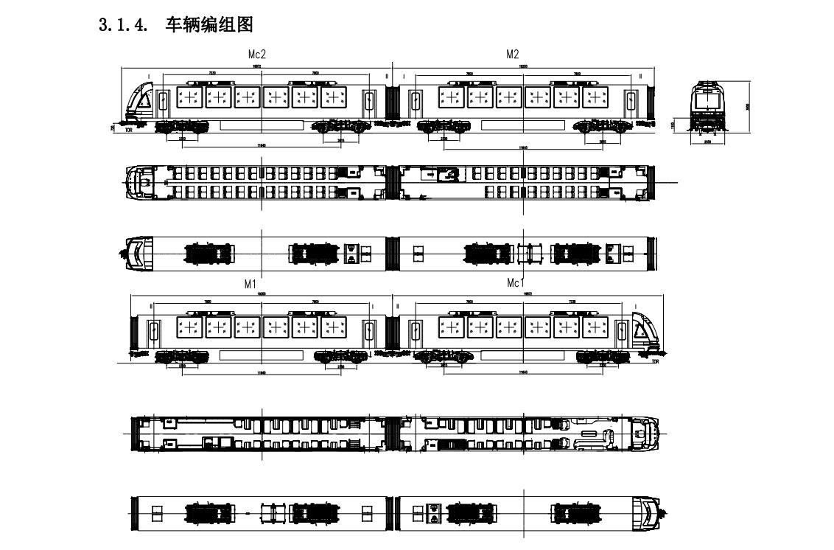

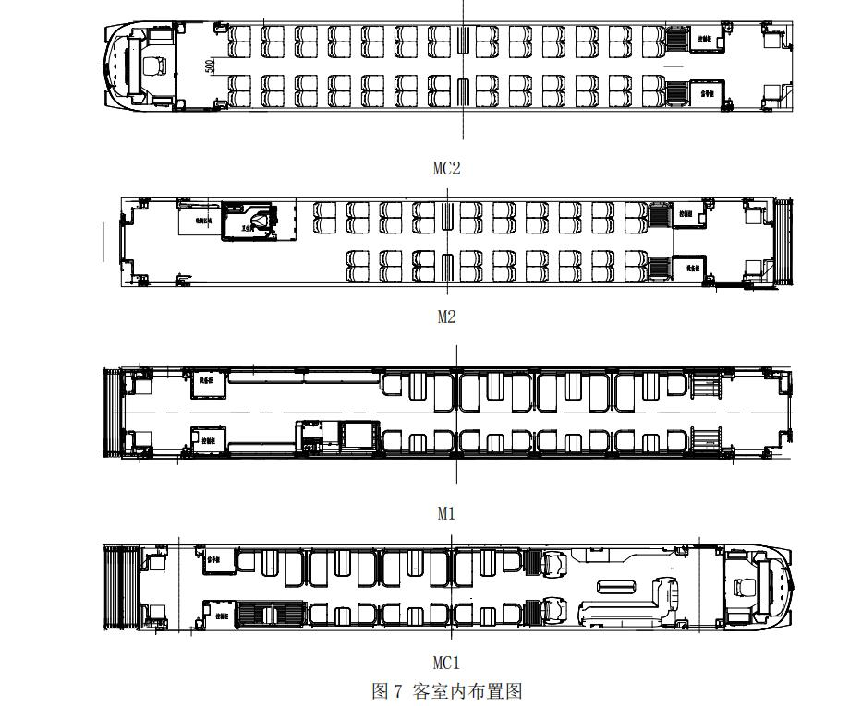

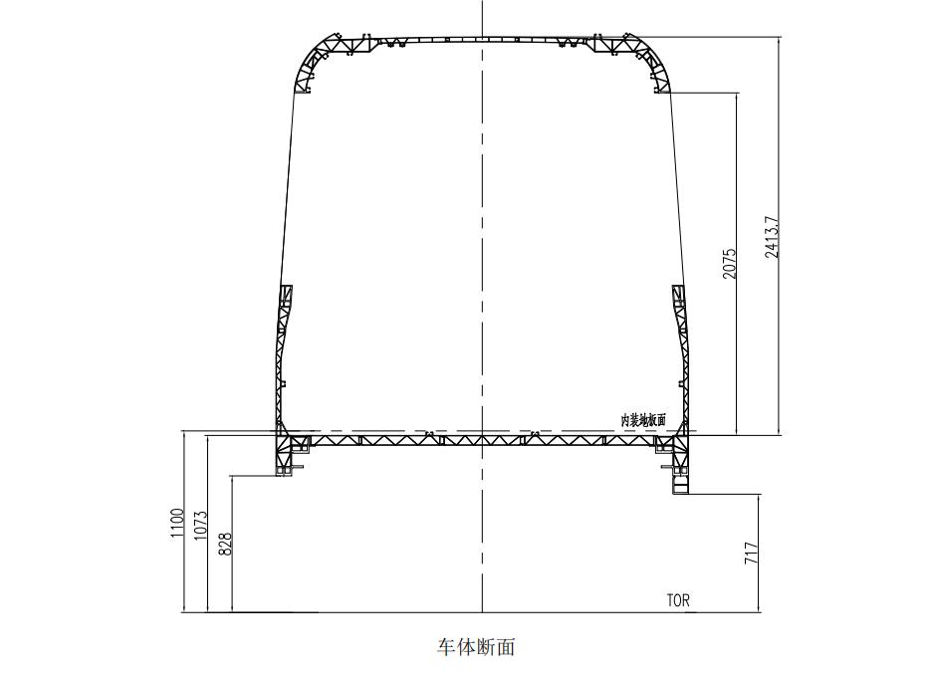

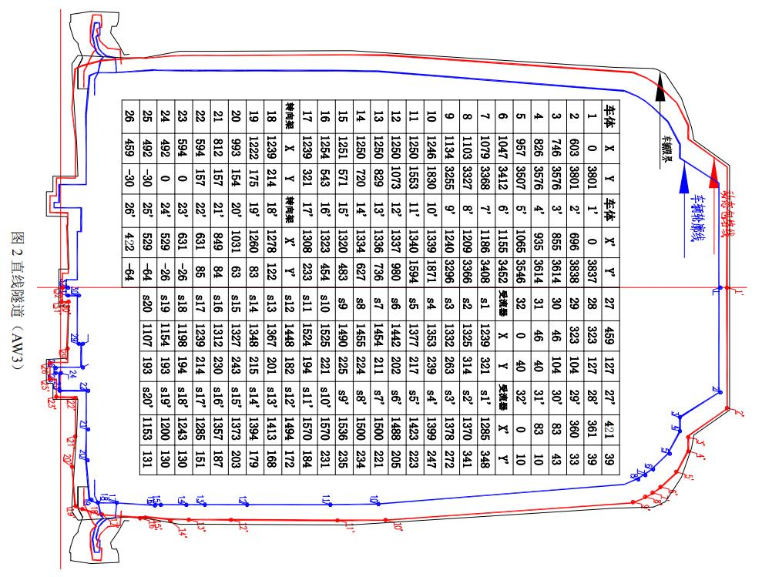

附件2：蜀道集团标识文件
Appendix 2: Signage Document of Shudao Investment Group Co., Ltd.
另附。
(attached separatel




第五章 应征文件格式
Chapter V Application Document Format

(项目名称)
(Project name)

应 征 文 件
Application Documents

应征人： (盖单位章)
Applicant: (affixed with the unit's official seal)

法定代表人或其委托代理人： (签字)
Legal representative or entrusted agent: (signature)

年 月 日
MM / DD / YY

一、应征函
I. Letter of Application

致 (征集人全称)：
To (full name of the Host)
1.我方全面研究了 (项目名称) 征集文件及征集补充文件(如 有时)，我们将遵照征集文件的要求承担本工程的全部工作。
1. Having comprehensively studied solicitation documents and its supplementary documents (if any) of (Project name), we would undertake all the work of the Project required in solicitation documents.
2.现递交我方应征文件正本壹份，副本贰份， 电子文档一套。
2. We hereby submit one original, two copies and one set of electronic documents of our application documents.
3.我方是本项目设计方案的真正设计人，同意征集文件中有关知识产权的规定。
3. The actual designer of the design scheme of the Project, we agree to the provisions on intellectual property rights in the solicitation documents.
4.本项目方案设计的设计总负责人为 (姓名、职称、职务)。
4. The chief designer of the Project scheme design is (name, professional title and position).
5.我方承诺一旦被定为第一阶段入围设计单位，(1)本项目方案设计的主创设计师承担本项 目全程设计工作； (2) 我方按业主要求和评审委员会评审意见，立即进行第二阶段方案深化设
5. We promise that once we are selected as the shortlisted design unit in the first stage, (1) the chief designer of the Project scheme design should undertake the whole design work of the Project; (2) following the requirements of the owner and the review opinions of the review jury, we will immediately carry out the development design of the scheme in the second stage until the finally selected agency is determined
计，直至第二阶段确定最终中选人。
in the very stage.

6．我方将接受并遵守征集文件所规定的各项条款。
6. We will accept and abide by the terms stipulated in solicitation documents.

应征人： (全称、盖章)
Applicant: (full name and affixed with the seal)
法定代表人或其委托代理人： (签字)
Legal representative or entrusted agent: (signature)
日期： 年 月 日
Date: DD/MM/YY

二、授权委托书或法定代表人身份证明

II. Power of Attorney or Identity Certificate of the Legal Representative

授权委托书
Power of Attorney
本人 (姓名) 系 (应征人名称) 的法定代表人，现委 托本单位人员 (姓名) 为我方代理人。代理人根据授权，以我方名义签署、 澄清、说明、补正、递交、撤回、修改 (项目名称) 应征文件，签订合同和 处理有关事宜，其法律后果由我方承担。
I, (name), the legal representative of (name of the applicant), hereby entrust ____ __ (name) in our unit as our agent. The agent is entrusted to sign, clarify, explain, supplement, submit, withdraw and modify the application documents of _________ _______ (Project name), sign contracts and deal with relevant matters in our name, with the legal consequences borne by us.
委托期限： 自本授权委托书签署之日起至应征有效期结束为止。
Term of entrustment: From the date of signing this Power of Attorney to the end of the validity period of the application.
代理人无转委托权。
The agent has no right to assign entrustment.
附：法定代表人身份证和委托代理人身份证扫描件 (复印件)
Attached: Scanned copies of the ID of the legal representative and that of the entrusted agent (Photocopies)

应征人： (全称、盖章)
Applicant: (full name and affixed with the seal)
法定代表人： (签字)
Legal representative: signature)
委托代理人： (签字)
Entrusted agent: (signature)
日期： 年 月 日
Date: DD/MM/YY

注：(1) 法定代表人不亲自应征而委托代理人应征适用。
Note: (1) It is applicable to the legal representative who fails to apply in person but entrusts an agent to apply.
(2) 法定代表人委托他人应征的，委托代理人应是应征人本单位的人员。
(2) If the legal representative entrusts others to apply, the entrusted agent should be the staff of the applicant's own unit.

法定代表人身份证明
Identity Proof of the Legal Representative

应征人名称：
Name of the applicant:
姓名： 系 (应征人名称) 的法定代表人 (职务： ；电话： )。
It is hereby to certify that: _______ (name) is the legal representative of (name of the applicant)
.
特此证明。
(Position: ; Tel: )

附：法定代表人身份证复印件
Attached: A photocopy of the ID of the legal representative

应征人： (全称、盖章)
Applicant: (full name and affixed with the seal)
日期： 年 月 日
Date: DD/MM/YY

注：法定代表人亲自应征而不委托代理人应征适用。
Note: It is applicable to the legal representative who applies in person instead of entrusting an agent to apply.

三、作品版权原创承诺书

III. Letter of Commitment for the Originality of Work Copyright

四川都金山地轨道交通有限责任公司：
Sichuan Dujin Mountain Rail Transit Co., Ltd.
本单位投送给贵单位的“都江堰至四姑娘山山地轨道交通扶贫项目地面及高架车 站站房概念方案设计”为原创作品 ，未侵犯任何他人著作权 、专利权及受相关法律法 规保护的其他设计 内容 。本作品未向其他单位投送 ，未以任何形式发表 ，未在其他地 方使用 。若本作品涉及抄袭 、借用 、一稿 多投 、未经授权使用等侵权行为 ，均由本单 位承担一切后果 ， 与征集单位无关。
The "Conceptual Scheme Design of Ground and Elevated Station Buildings of Mountain Rail Transit Poverty Alleviation Project from Dujiangyan to Siguniang Mountain" submitted by us to you is an original work that will not infringe the copyright, patent right and other design contents protected by relevant laws and regulations. This work has not been delivered to other units, published in any form, or used elsewhere. In case that this work is involved in plagiarism, borrowing, multiple submissions, unauthorized use and other infringement acts, we will bear all consequences, and the Host will not be held accountable.
作品一经投稿 ，即视为本单位 同意贵单位拥有投稿作品的全部知识产权，本单位 无条件配合贵单位办理相关知识产权登记或转让手续，该作品知识产权归贵单位所 有 ， 并且贵单位有权进行修 改和使用 ， 本单位拥有该作品的著作权。
It is hereby committed that: Once the work is submitted, it is deemed that we agree that you own the entire intellectual property of the submitted work. We unconditionally cooperate with you in handling the relevant intellectual property registration or transfer procedures. Owning the intellectual property of the work, you are entitled to modify and use it,
特此承诺！
while we possess the copyright of the work.

应征人： (全称、盖章)
Applicant: (full name and affixed with the seal)
日期： 年 月 日
Date: DD/MM/YY

四、资格审查资料

IV. Qualification review materials
1、应征人基本情况表
1. Table for the Applicant's Basic Information

序号  Serial number | 项目  Item | 内容  Content | 备注  Remarks
1 | 公司注册名称  Registered name of the company
2 | 公司：  The company:
2 | a.法定代表人  a. Legal representative
2 | b.公司注册地址  b. Registered address of the company
2 | c.公司成立日期  c. Incorporation date of the company
2 | d.公司地址  d. Address of the company
2 | e. 电话  e. Tel
2 | f.传真  f. Fax
2 | g. 电子邮箱  g. Email
3 | 公司类别：有限责任公司/合伙人/其它  Company type: Limited liability company (LLC) / partnership / others
4 | 商业登记/营业执照：(附执照复印件并加盖公章)  Business registration/business license: (Attached with a photocopy of the license with the official seal affixed)
4 | a.登记证编号  a. Registration certificate No.
4 | b.登记证日期  b. Date of registration certificate
4 | c.登记地  c. Registered location
5 | 公司设计资质的种类及级别 (附资质复印件并加盖公章)  Type and grade of the company's design qualification (attached with a photocopy of the qualification with the official seal affixed)

4、应征人业绩表
4. Table for the Applicant's Achievements
序号：
Serial number:

序号  Serial number | 项目  Item | 内容  Content | 备注  Remarks
1 | 项目名称  Project name
2 | 项目地点  Project location
3 | 所承担的设计内容  Design content undertaken
4 | 在项目设计中的合同关系：  Contractual relationship in project design:
4 | a.设计总包单位  a. Design general contractor
4 | b.设计分包单位  b. Design subcontractor |  | 须注明其所承担的具体设 计内容  It is required to indicate the specific design content undertaken.
4 | c..设计联合体代表人  c. Design consortium representative
4 | d.设计联合体成员  d. Design consortium members |  | 须注明其所占有的权益份 额和承担的具体设计内容  It is required to indicate the share of rights and interests held and the specific design content undertaken.
5 | 工程总造价  Total cost of the project
6 | 项目规模 (用地面积,建筑面 积)  Project scale (site area, floor area)
7 | 合同完成情况  Contract completion status
8 | 延迟原因 (如有延迟的话)  Reason for postponement (in case of postponement)
9 | 业主名称  Name of owner
9 | 通讯地址  Mailing address
9 | 传真及电话  Fax and telephone
10 | 应征申请人投入该项 目 的主 规划师、建筑师和其他专业的 主设计师的姓名以及他们的 职务、作用和责任。  The names, positions, roles and responsibilities of the chief planners, architects and chief designers in other specializations to be assigned by the applicant for the Project.
11 | 简述项目概况。  Brief Project overview
注：每个业绩单独填写一张表，应征人应提供合同复印件或中标 (选) 通知书等相关证明资料 复印件。
Note: One table should only carry one achievement. The applicant should provide photocopies of relevant supporting materials, such as that of the contract or that of the bid (selection)-winning notice.

五、方案设计
V. Scheme design
应征人根据自身情况编写方案设计， 内容与格式自拟。
The applicant should prepare the conceptual scheme design according to its own situation with self-prepared content and format.

六、应征人认为需要提供的其他资料 (如有)
VI. Other information that the applicant deems necessary to provide (if any)

